SwissLegal – one of the most attractive employers of 2017 in the legal area
With great pleasure we took notice of the student survey results published by Universum at the beginning of this month. As in the past year, SwissLegal ranked again among the top 20 companies in the field of law, and moreover, has made it to the top 10 employers among the Swiss law firms this year.
SwissLegal is represented in nine Swiss locations and advises with its experienced legal specialists companies and private persons in all matters of commercial and private law. With its law professors and lecturers, SwissLegal is also closely connected to universities and studies of applied sciences, and thus at the pulse of the latest law doctrine and research.
Due to the careful recruiting and selection of specialists as well as the expansion of the group, SwissLegal has also succeeded in establishing a practice in areas such as IT law, data protection and compliance in order to be already prepared for the questions of tomorrow. Hence, it is a great honour for us to be one of the most attractive Swiss Law firms from the perspective of the future generation of law specialists.
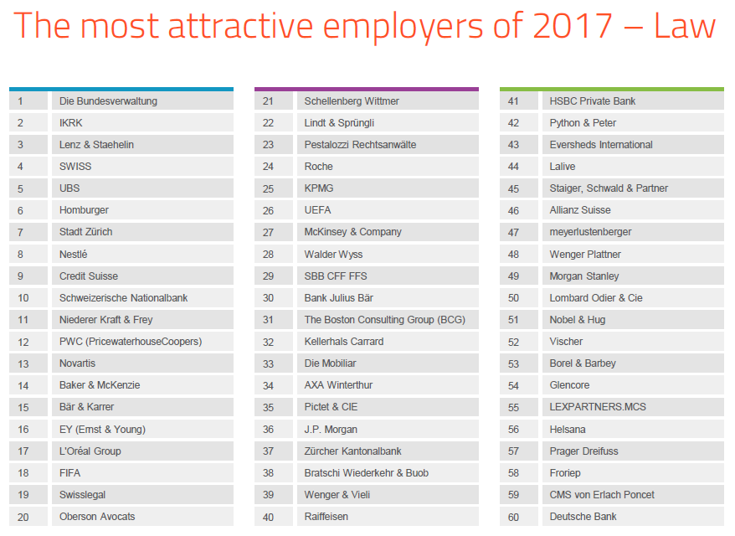
source: Universum (universumglobal.com), 2.10.2017

